**Name – Rani Kumari**

**Email** – [ranikumari17112001@gmail.com](mailto:ranikumari17112001@gmail.com)

**Course Name** – Business Analyst career Program (chat GPT )

**Assignment Title –** SQL (Major)

Q1) Create a table “ STATION ” to store information about weather observation stations:

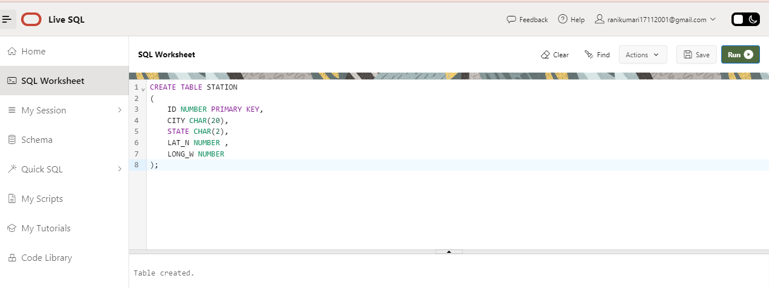

Q2) Insert the following records into the table:

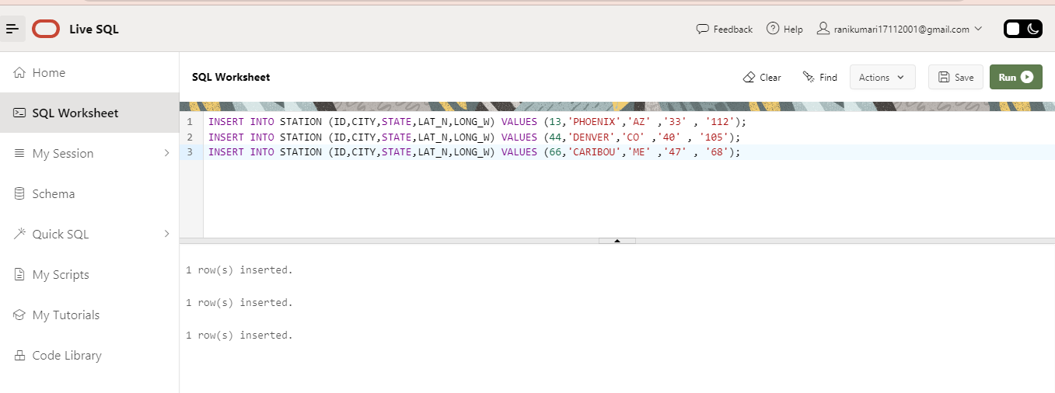

Q3) Execute a query to look at table STATION in undefined order.

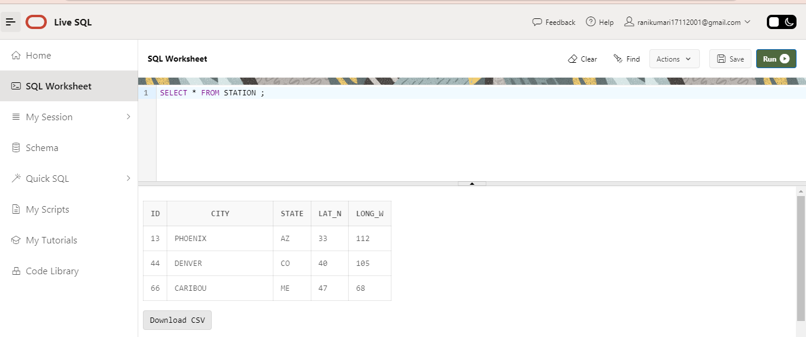

Q4) Execute a query to select Northern stations (Northern latitude > 39.7).

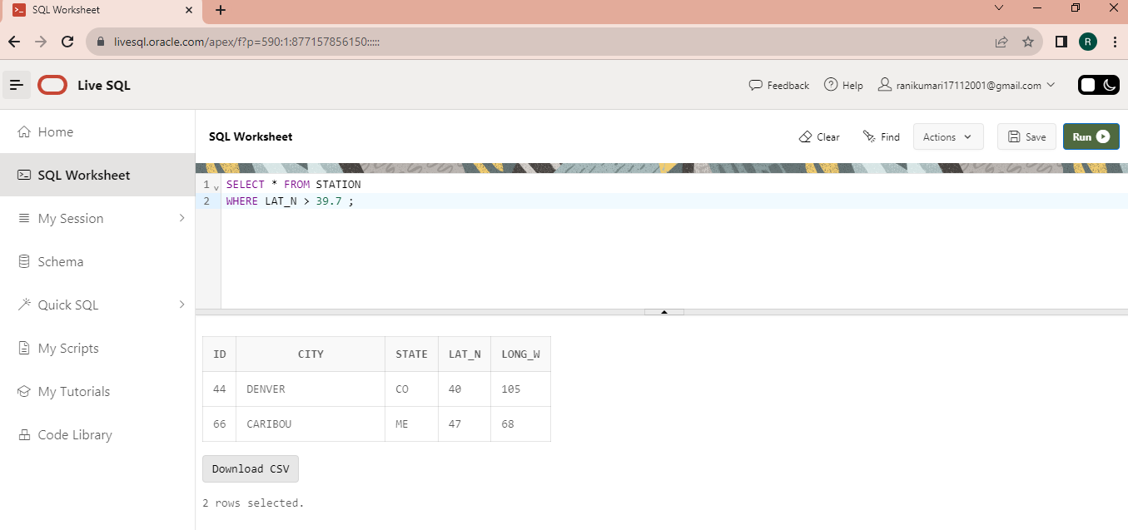

5. Create another table, ‘STATS’, to store normalized temperature and precipitation data:

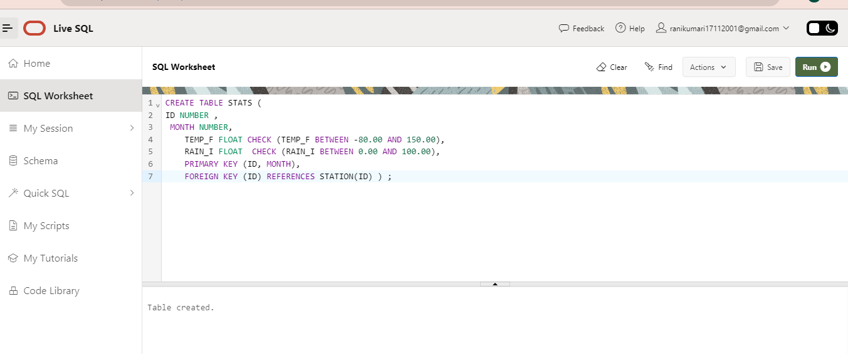

Q6) Populate the table STATS with some statistics for January and July:

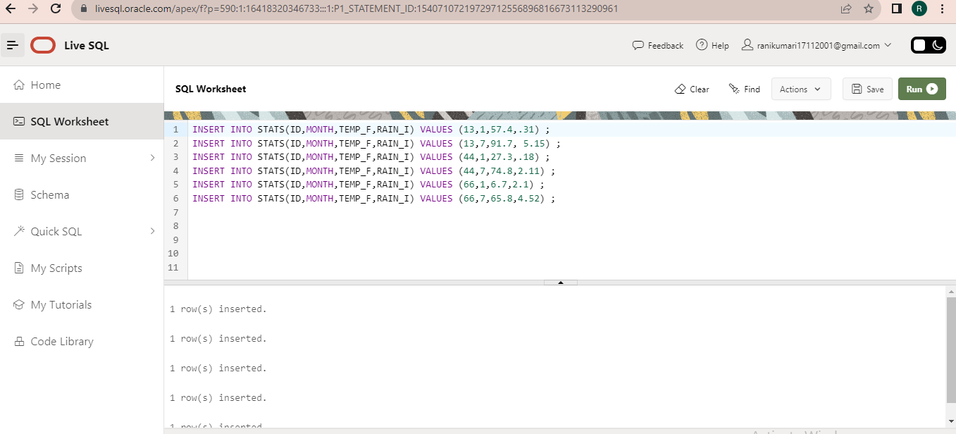

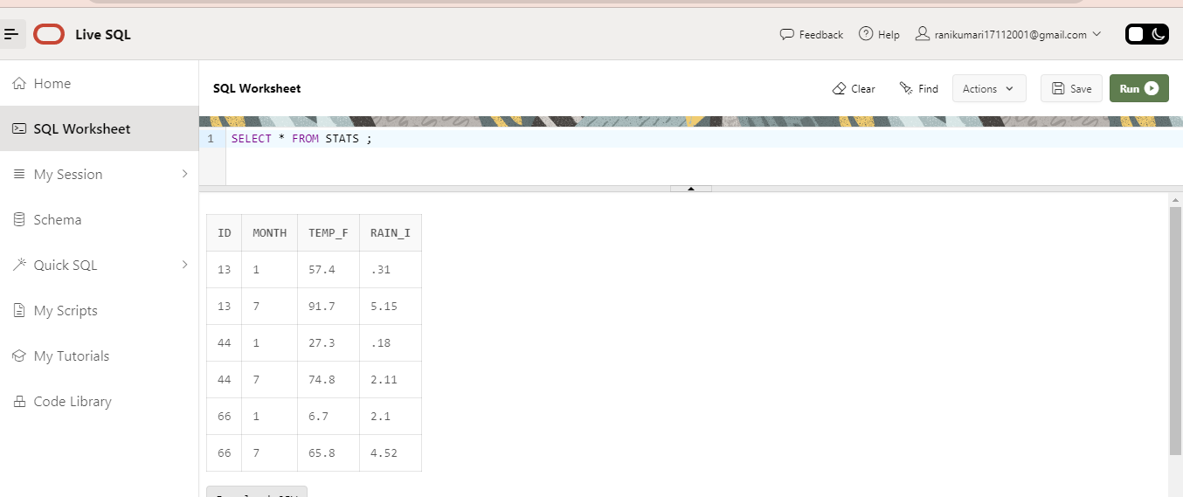

Q7) Execute a query to display temperature stats (from the STATS table) for each city (from the STATION table).

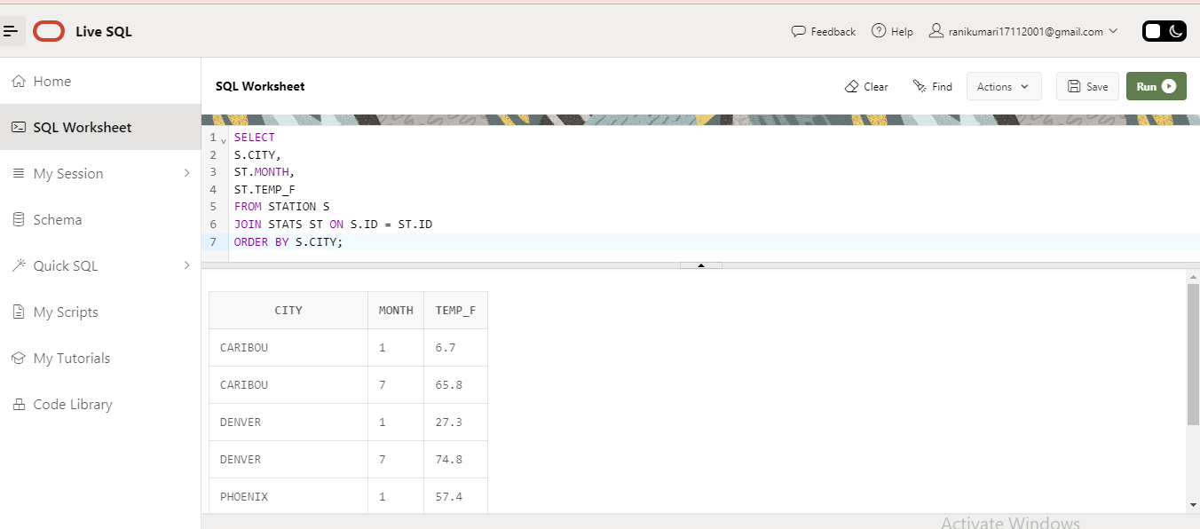

Q8) Execute a query to look at the table STATS, ordered by month and greatest rainfall, with columns rearranged. It should also show the corresponding cities.

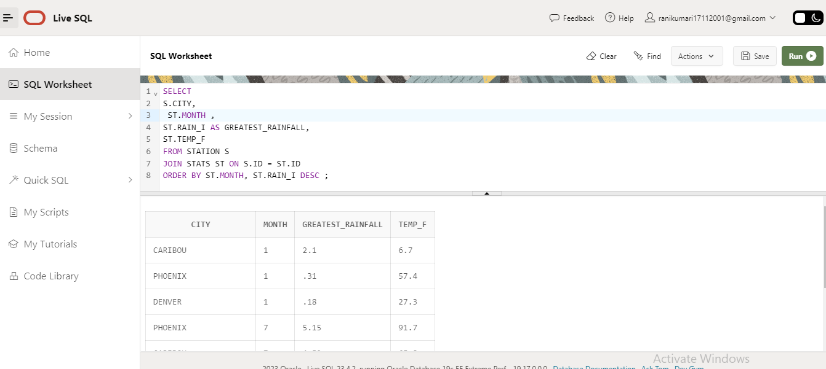

Q9) Execute a query to look at temperatures for July from table STATS, lowest temperatures first, picking up city name and latitude:

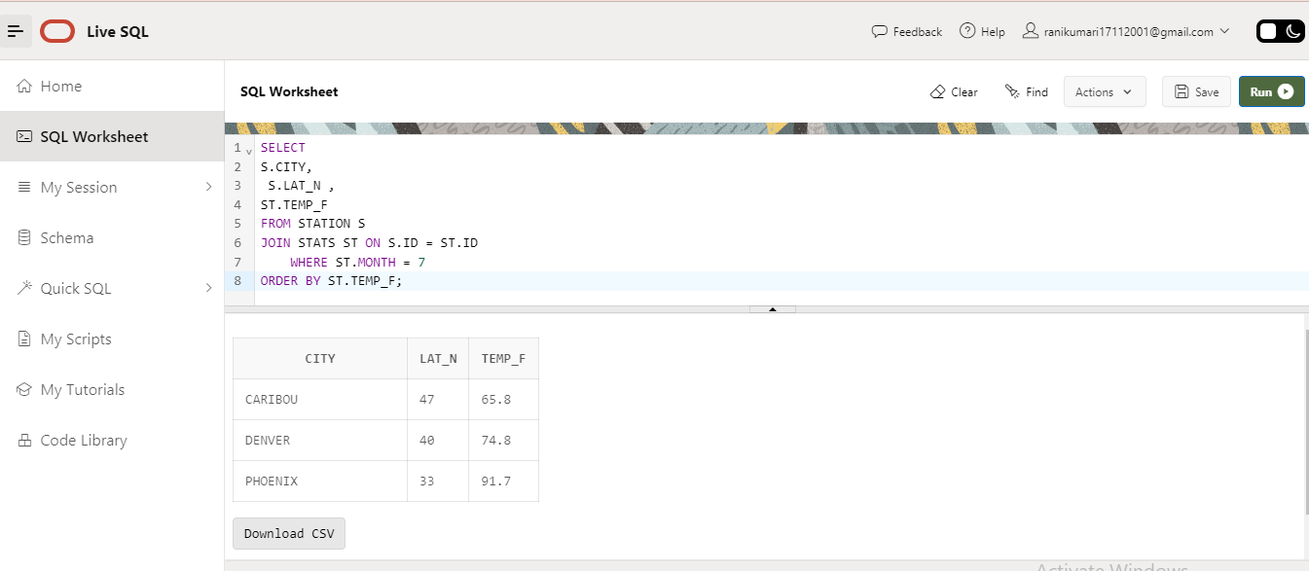

Q10) Execute a query to show MAX and MIN temperatures as well as average rainfall for each city.

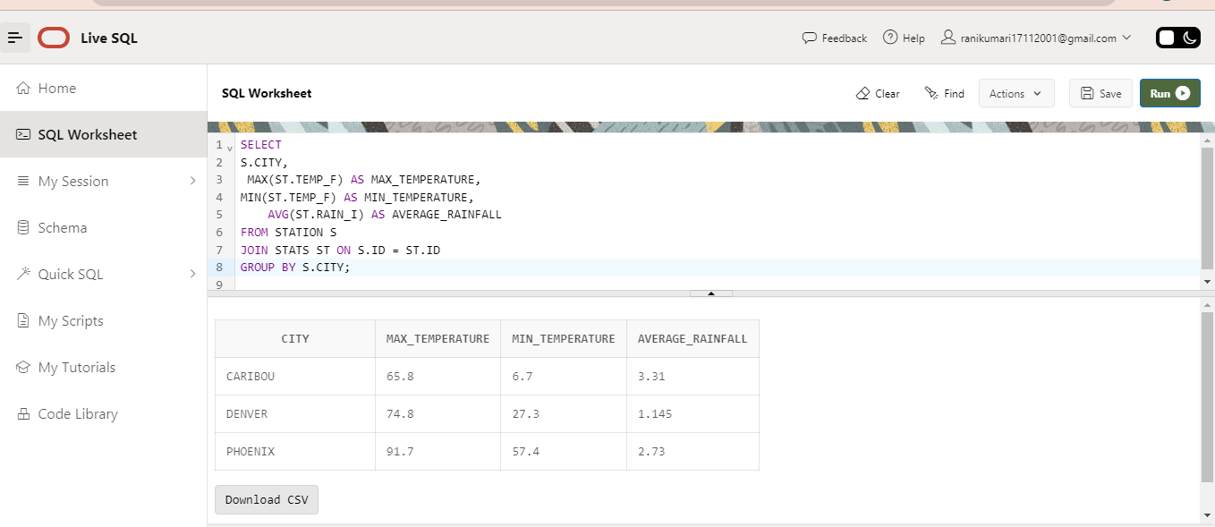

Q11) Execute a query to display each city’s monthly temperature in Celcius and rainfall in Centimeter.

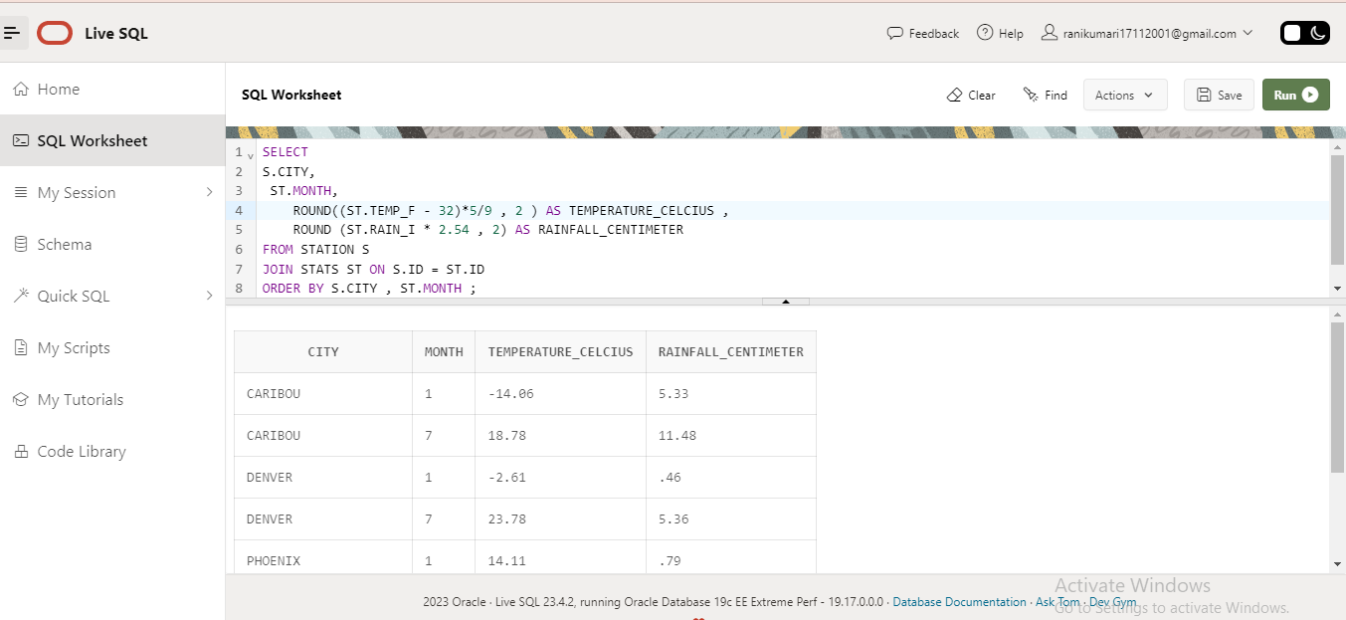

Q12) Update all rows of table STATS to compensate for faulty rain gauges known to read 0.01 inches low.

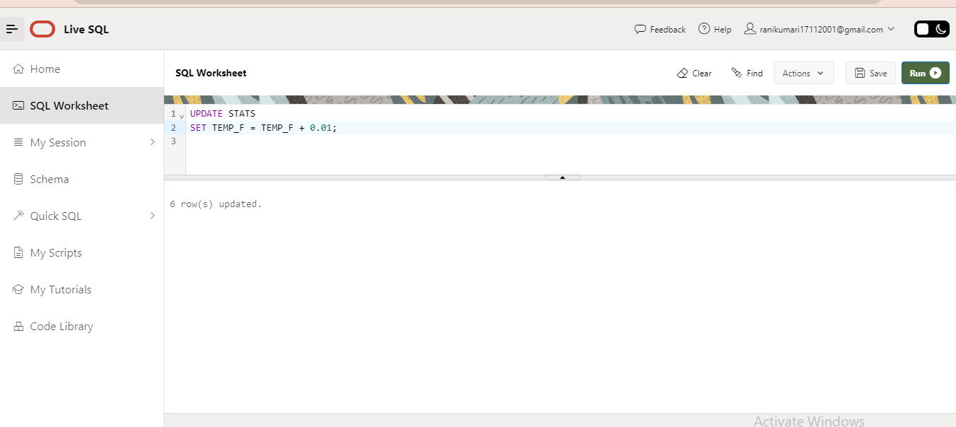

Q13) Update Denver's July temperature reading as 74.9.

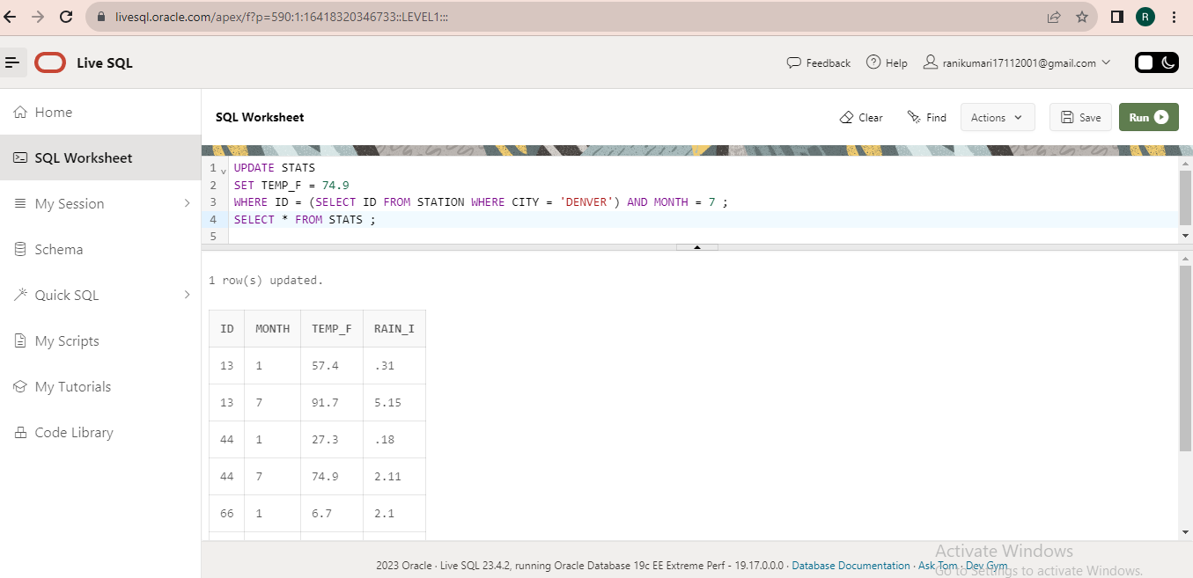

Name – Rani Kumari

Email – [ranikumari17112001@gmail.com](mailto:ranikumari17112001@gmail.com)

Course Name – Business Analyst Career Program (Chat GPT )

Assignment Title – SQL (Major)

**Thank You**